**OCCUPATIONS (WHO)**

1. Who are the speakers talking about?   
(A) A hairstylist.  
(B) A ticket-seller.  
(C) A concert pianist.  
(D) A singer.

2. Who are the speakers waiting for?   
(A) The delivery person with lunch.  
(B) The telephone technician.  
(C) The television salesman.  
(D) The computer programmer.

3. Who are the speakers waiting for?   
(A) A cab driver.  
(B) A friend.  
(C) A waitress.  
(D) A client.

4. Who are the speakers?  
(A) Teachers.  
(B) Police officers.  
(C) Accountants.  
(D) Travel agents.

5. Who is coming this afternoon?  
(A) An athlete.  
(B) An accountant.  
(C) A carpenter.  
(D) A math teacher.

6. Who is giving advice?  
(A) A doctor.  
(B) A waiter.  
(C) An exercise coach.  
(D) An athlete.

7. Who is waiting?  
(A) A gardener.  
(B) A taxi driver.  
(C) A mail carrier.  
(D) A musician.

8. Who left a phone message?  
(A) A taxi driver.  
(B) A tennis coach.  
(C) A telephone repairperson.  
(D) An auto mechanic.

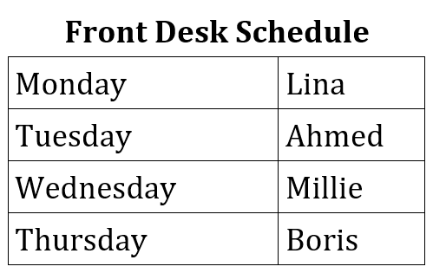9. Look at the graphic. Who will speaker with the painters?  
(A) Lina.  
(B) Ahmed.  
(C) Millie.  
(D) Boris.

10. Who is the woman talking to?  
(A) An athlete.  
(B) A musician.  
(C) A travel agent.  
(D) A police officer.